# Task 3: Lambda function to create EC2 instance

- Create S3 Bucket and integrate lambda function to it,

- whenever file is uploaded to S3 Bucket Lambda function will create an EC2 instance.

- Send S3 Bucket name to Outputs

- While Deleting CF Stack, it should delete EC2 Instance + S3 Bucket (also delete objects from bucket) and all resources should be deleted.

## Pre-Checks

### CF Stack

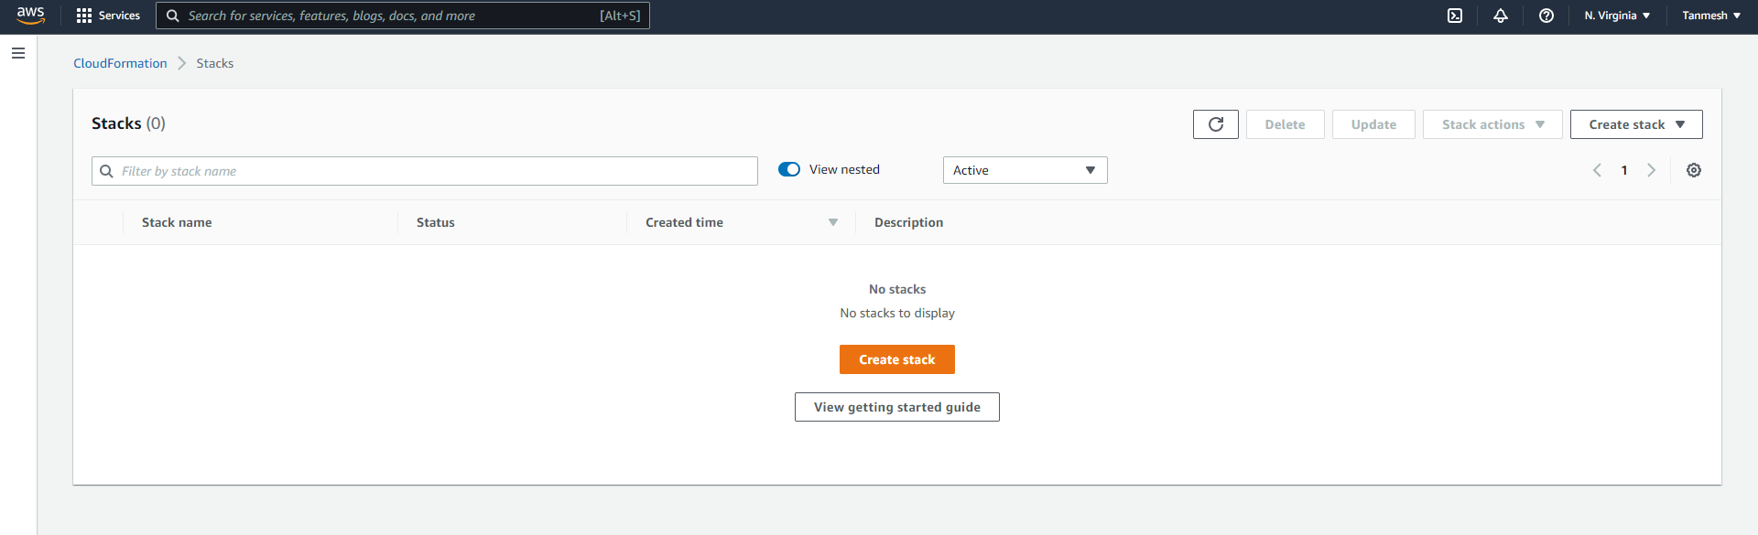

### EC2 Instance

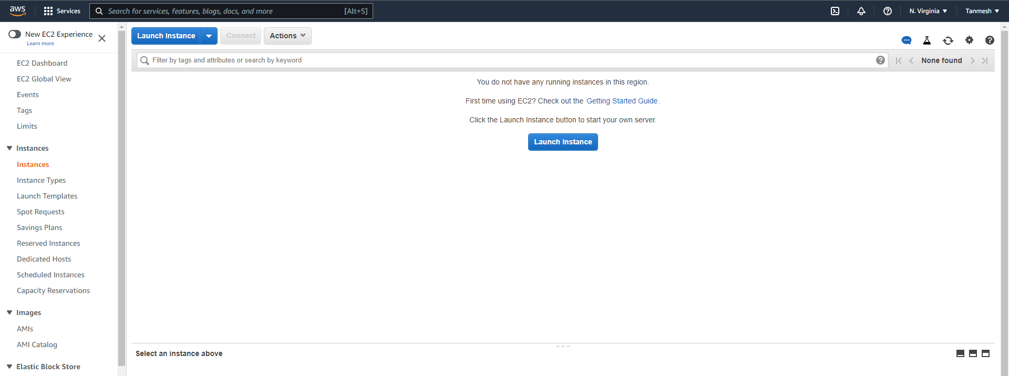

### Lambda Function

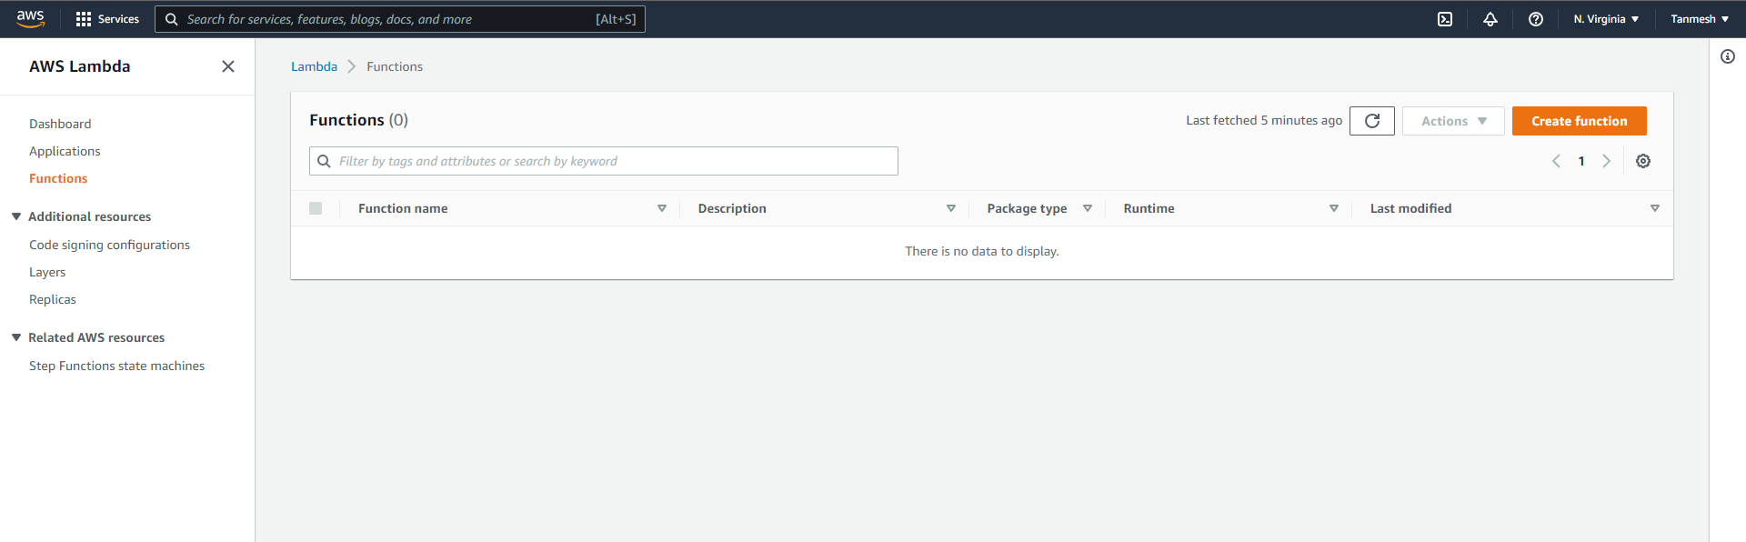

### S3 Bucket

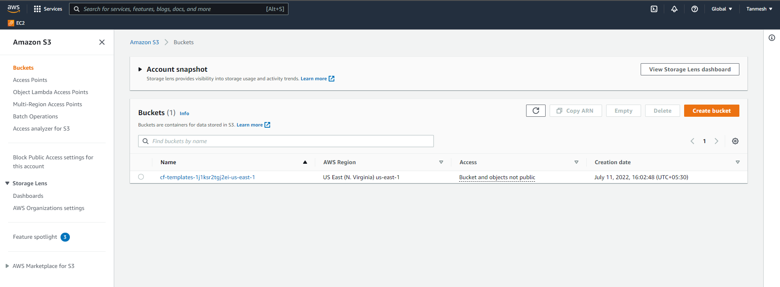

### IAM Roles

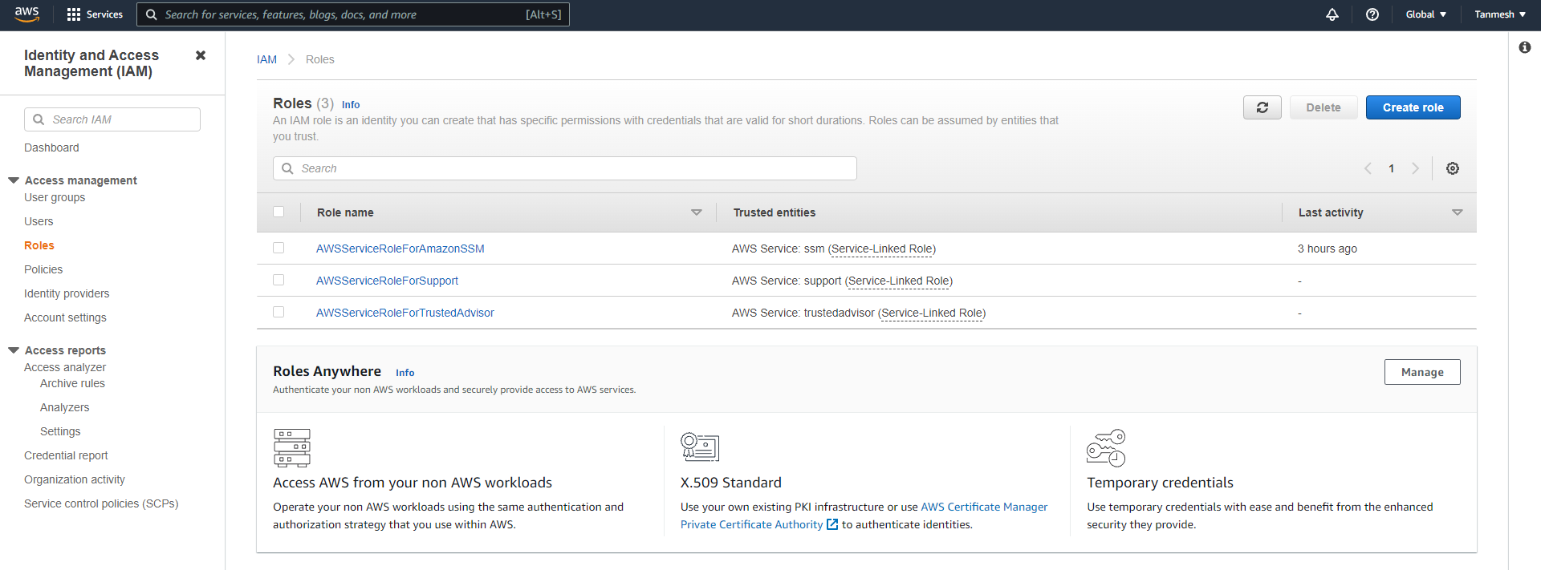

## Create CloudFormation Stack

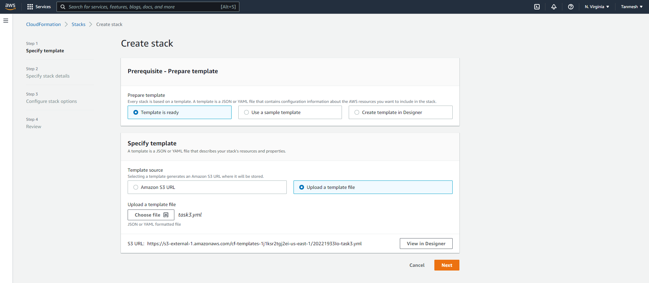

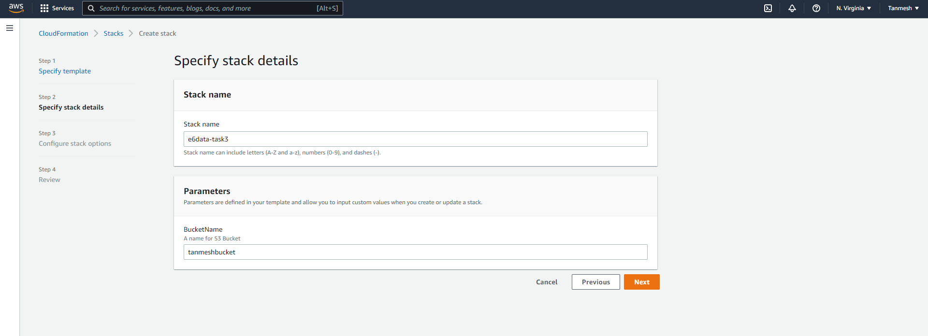

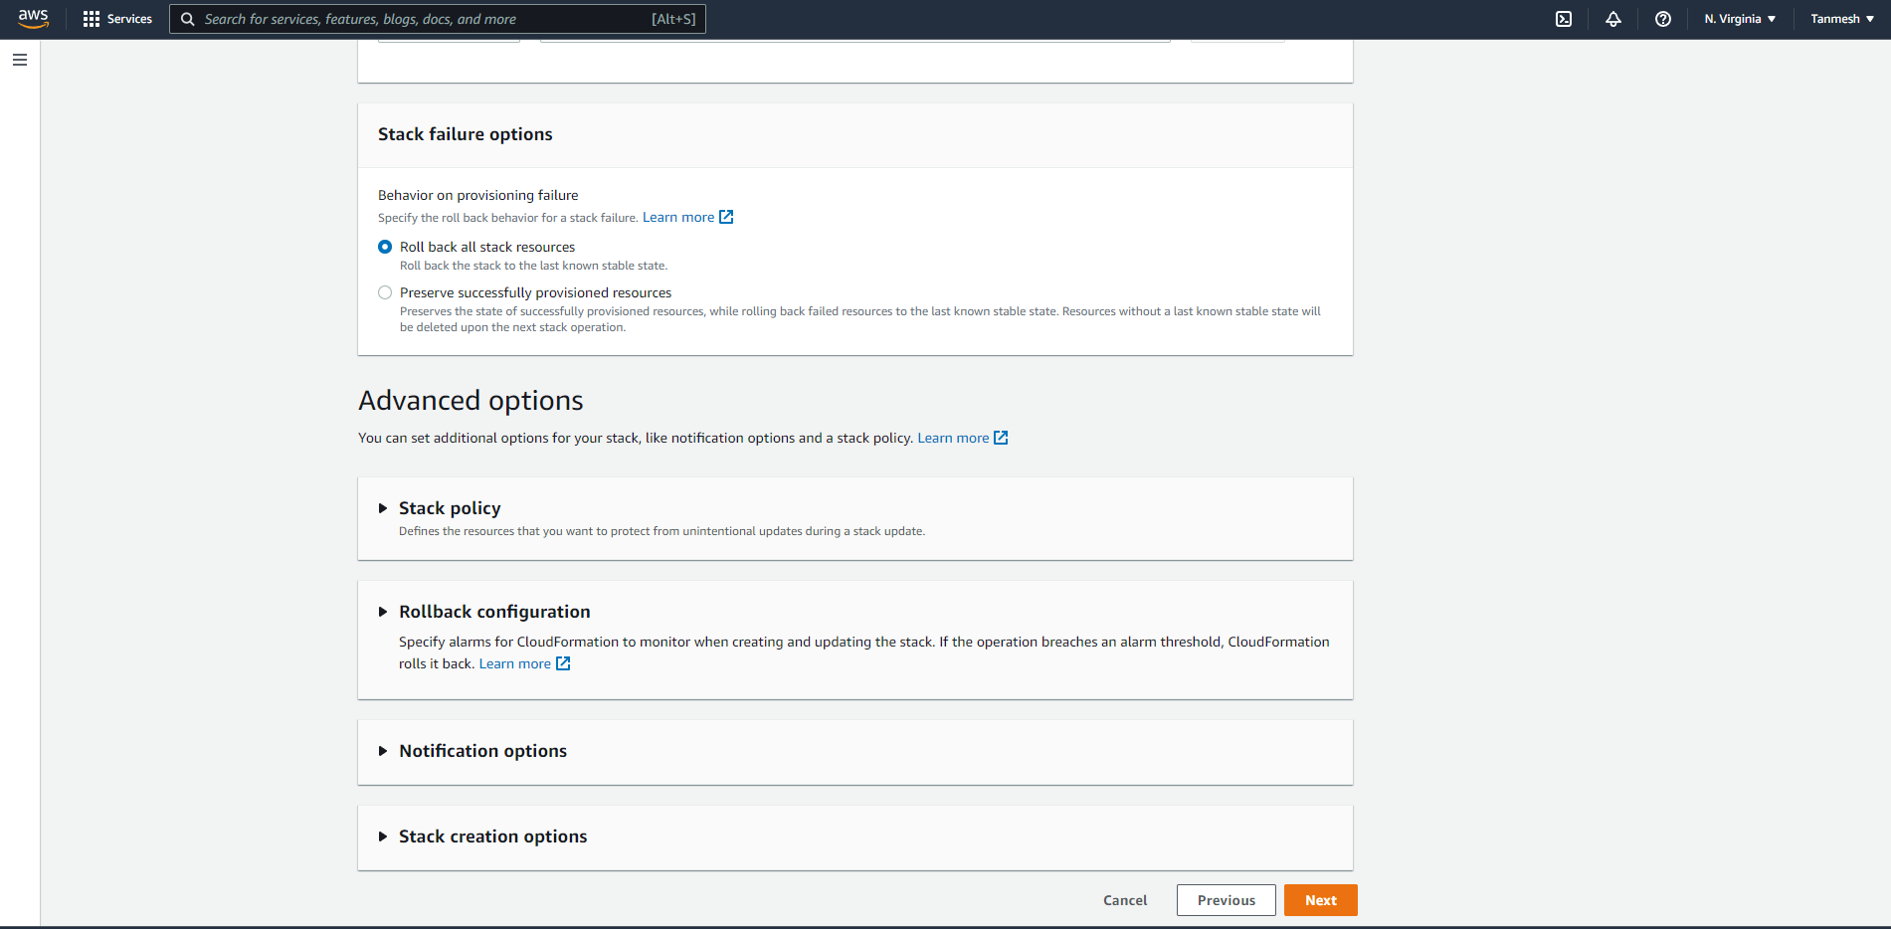

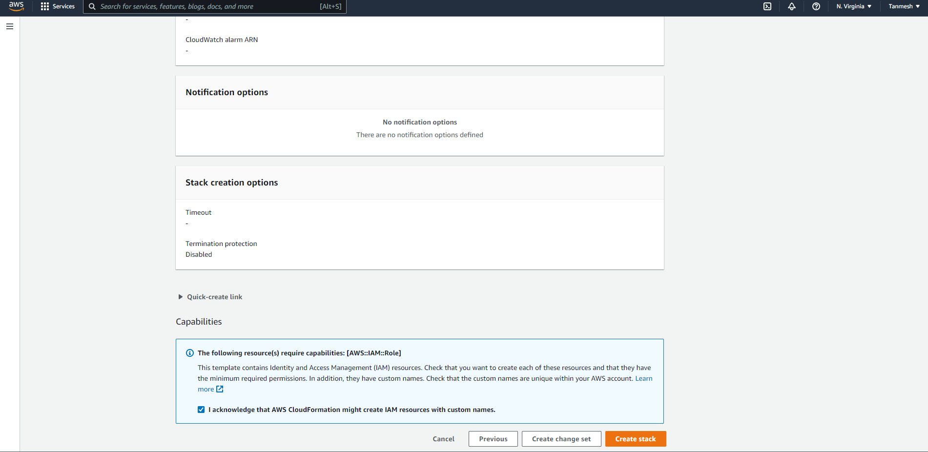

### Events

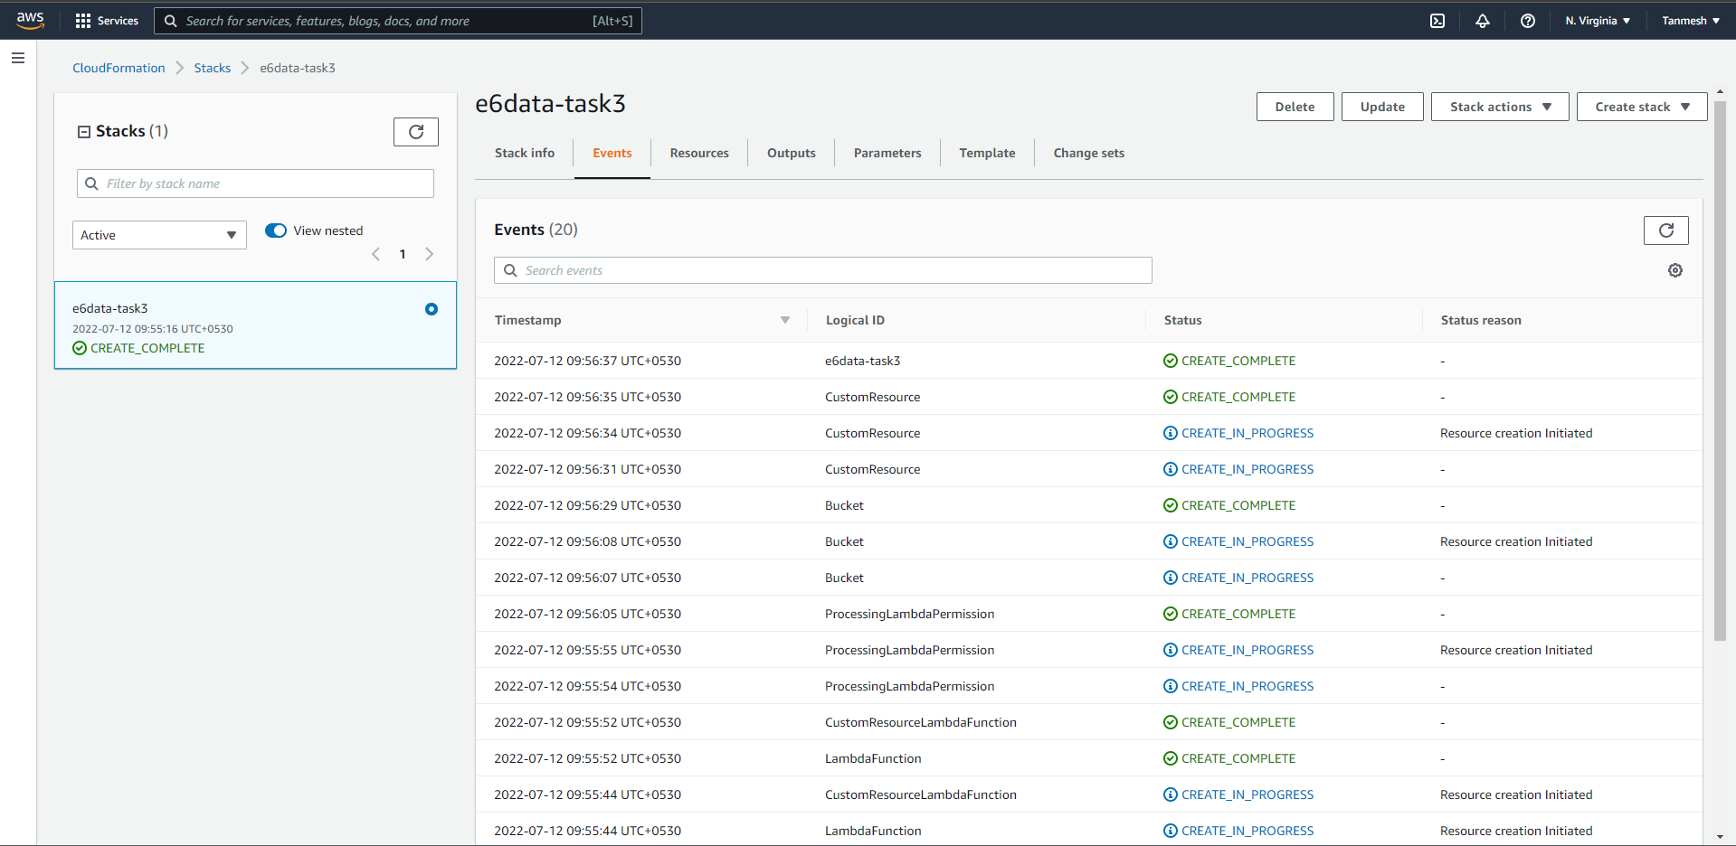

### Created Resources

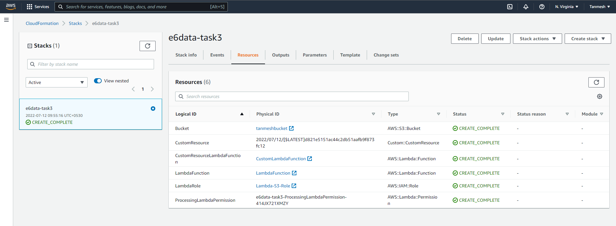

### Outputs

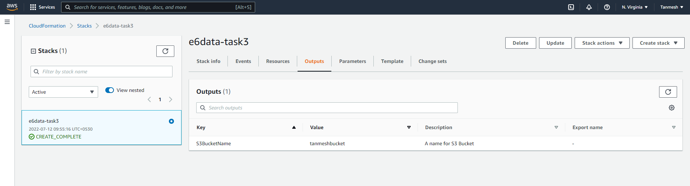

### Overview

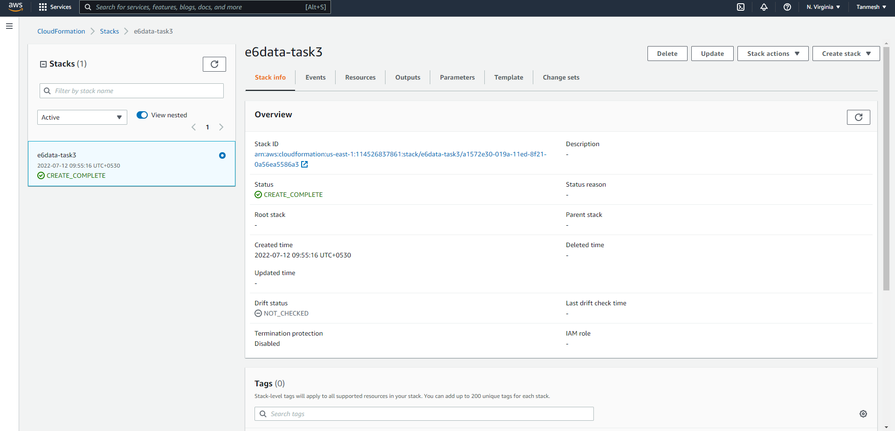

## Post Checks

### CF Stack

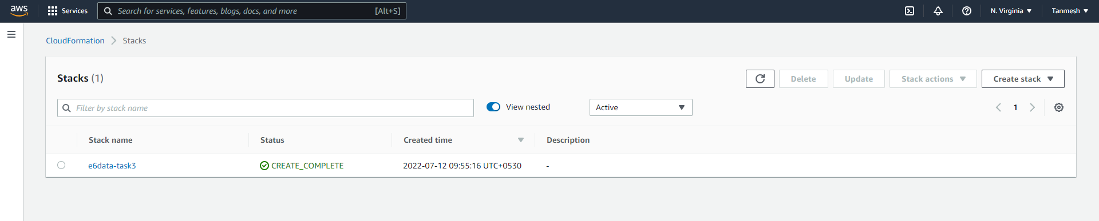

### EC2 Instance

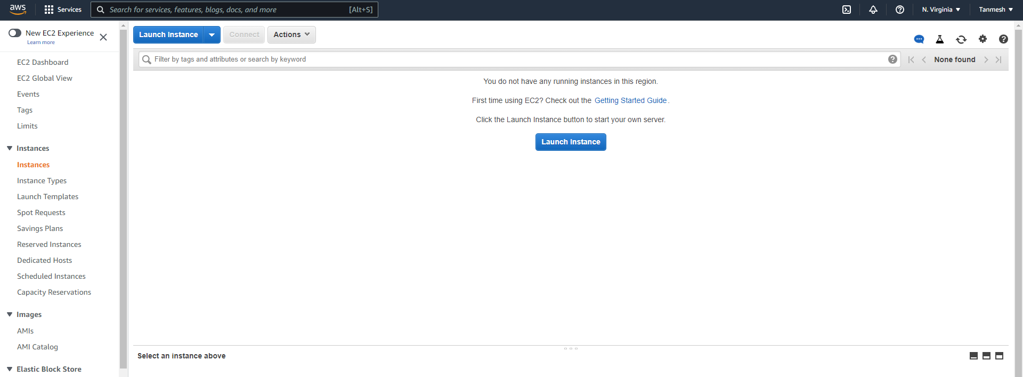

### Lambda Function

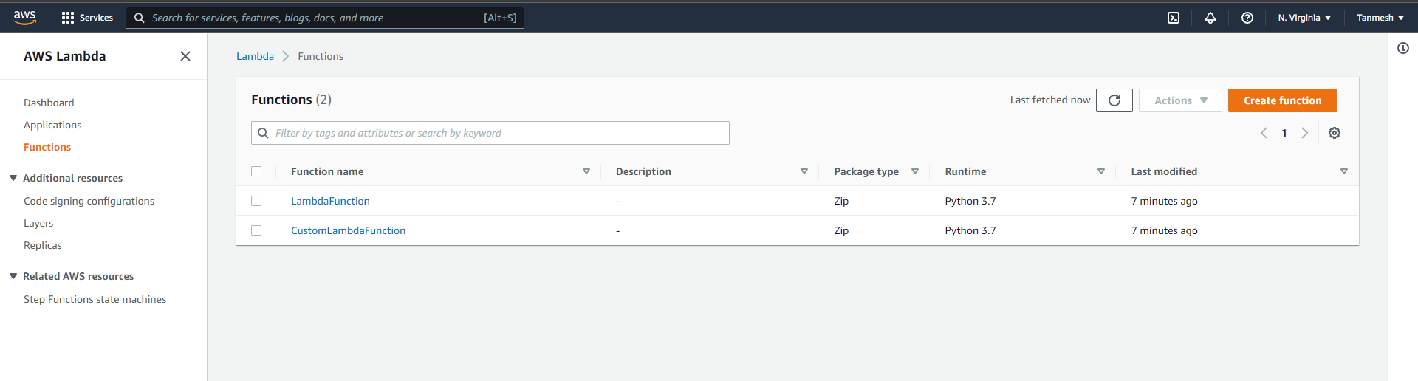

### S3 Bucket

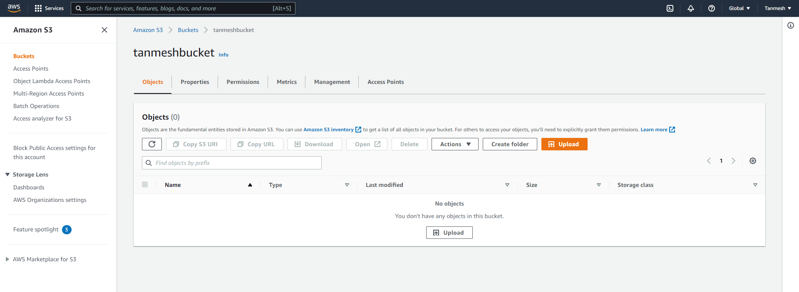

### IAM Roles

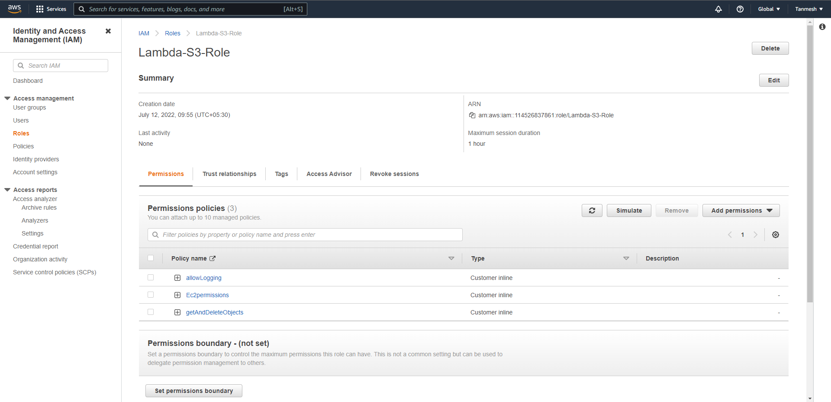

## Upload File to S3 Bucket and Validate EC2 Instance is created

### Upload file to S3

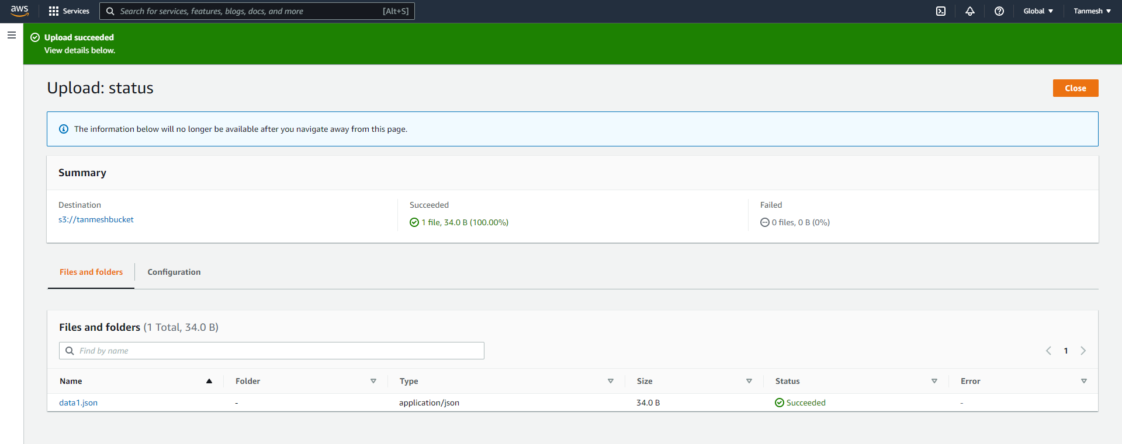

### EC2 Instance created

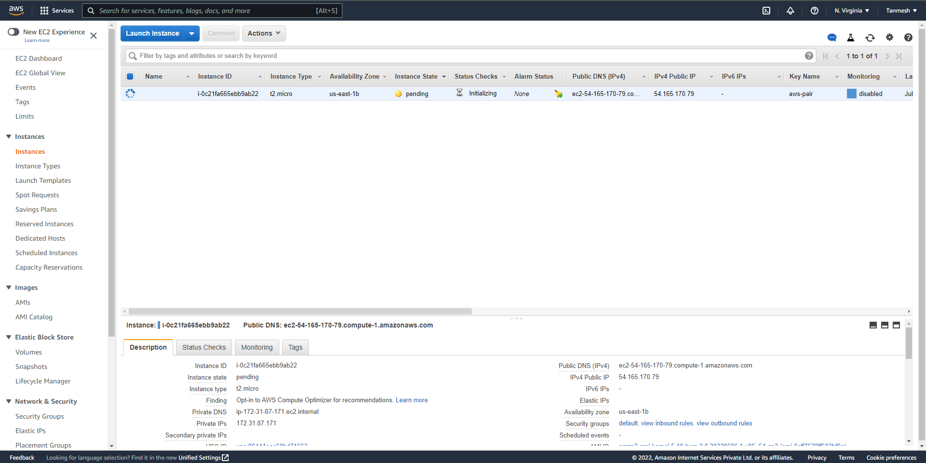

### Logs

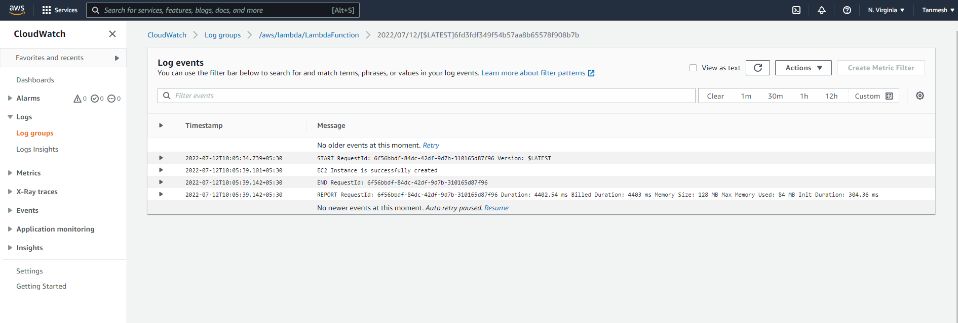

## Delete CF Stack (should delete S3Bucket Object and EC2 Instance)

### Before Delete

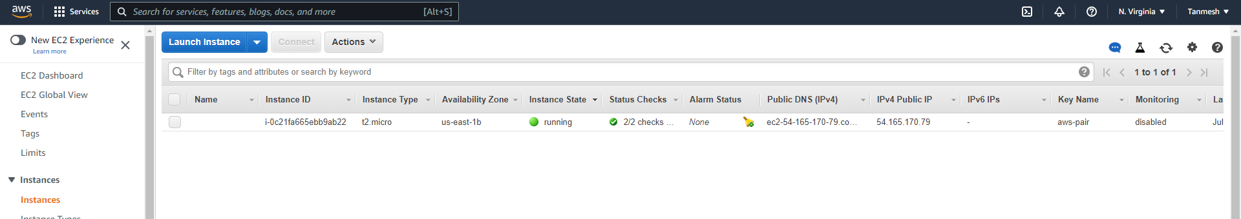

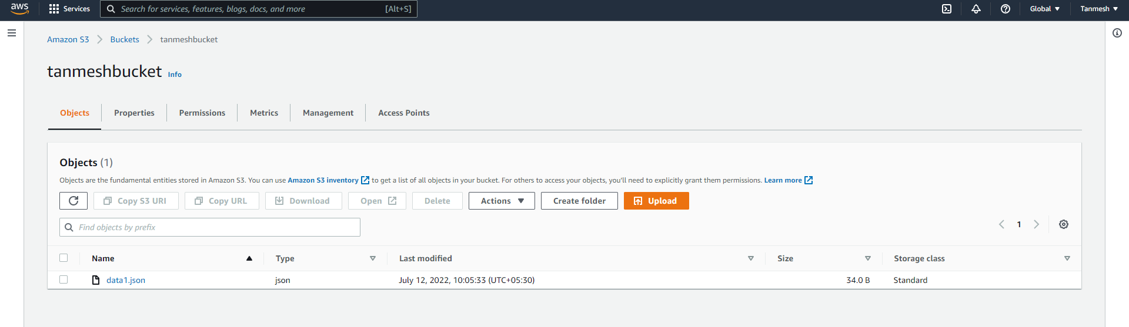

### Delete Stack

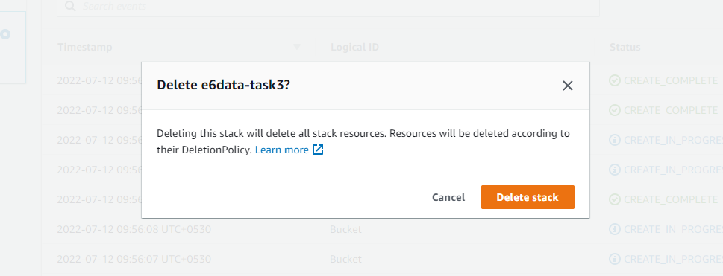

### After Delete

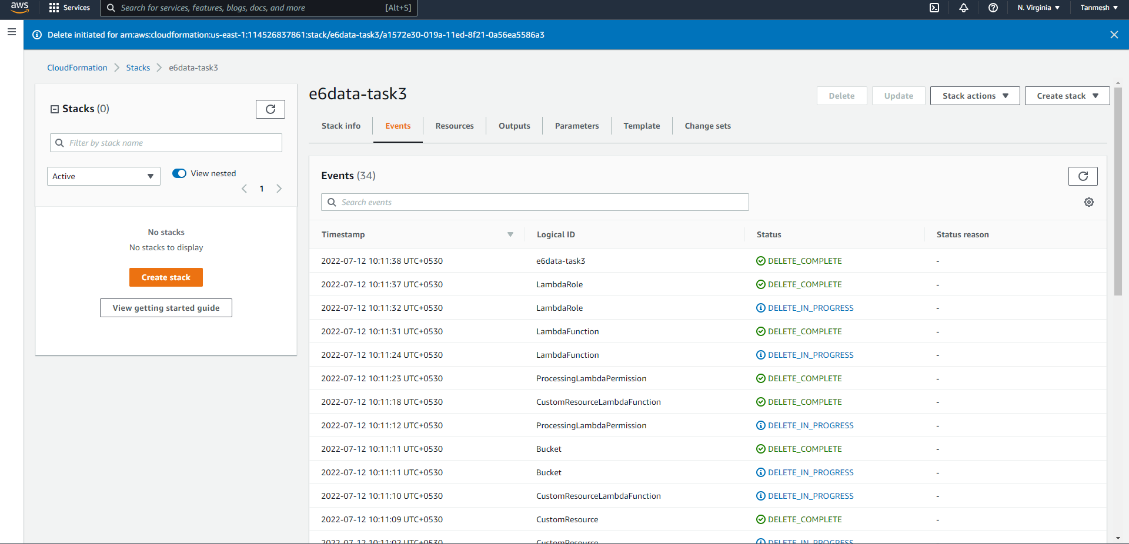

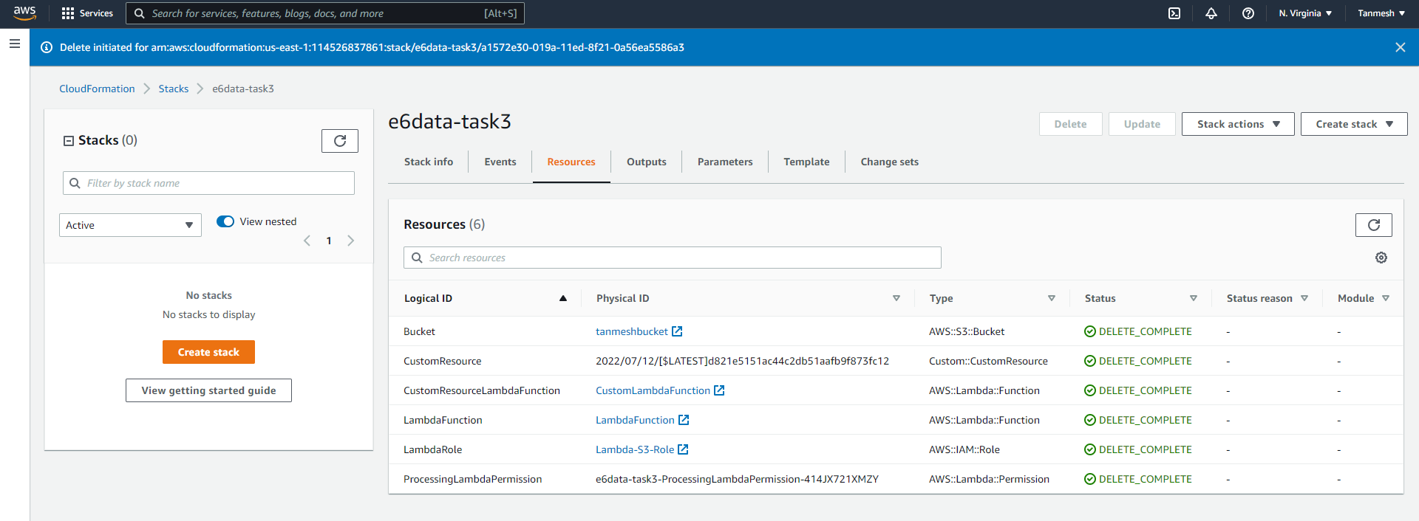

### EC2 Instance is terminated

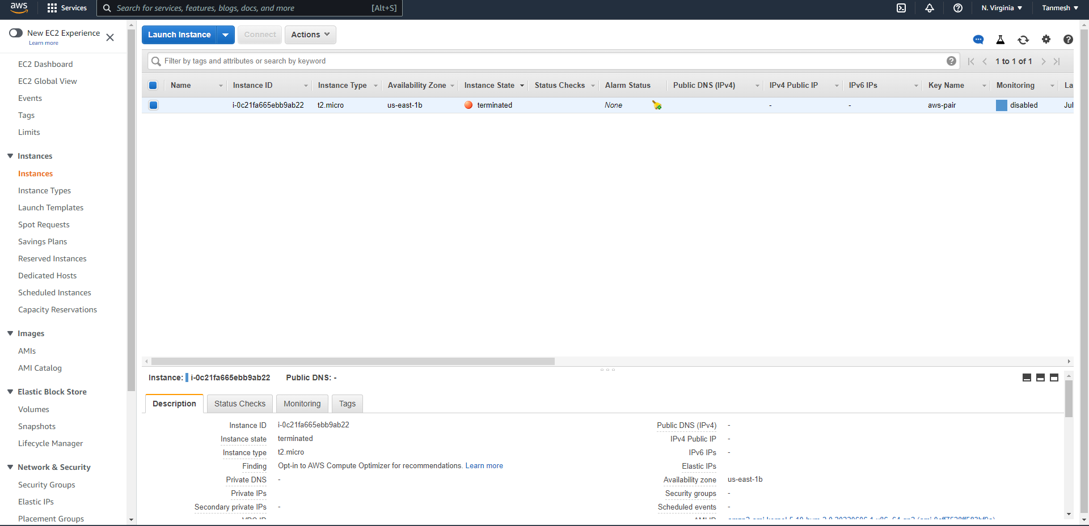

### S3 Bucket is deleted along with underlying objects

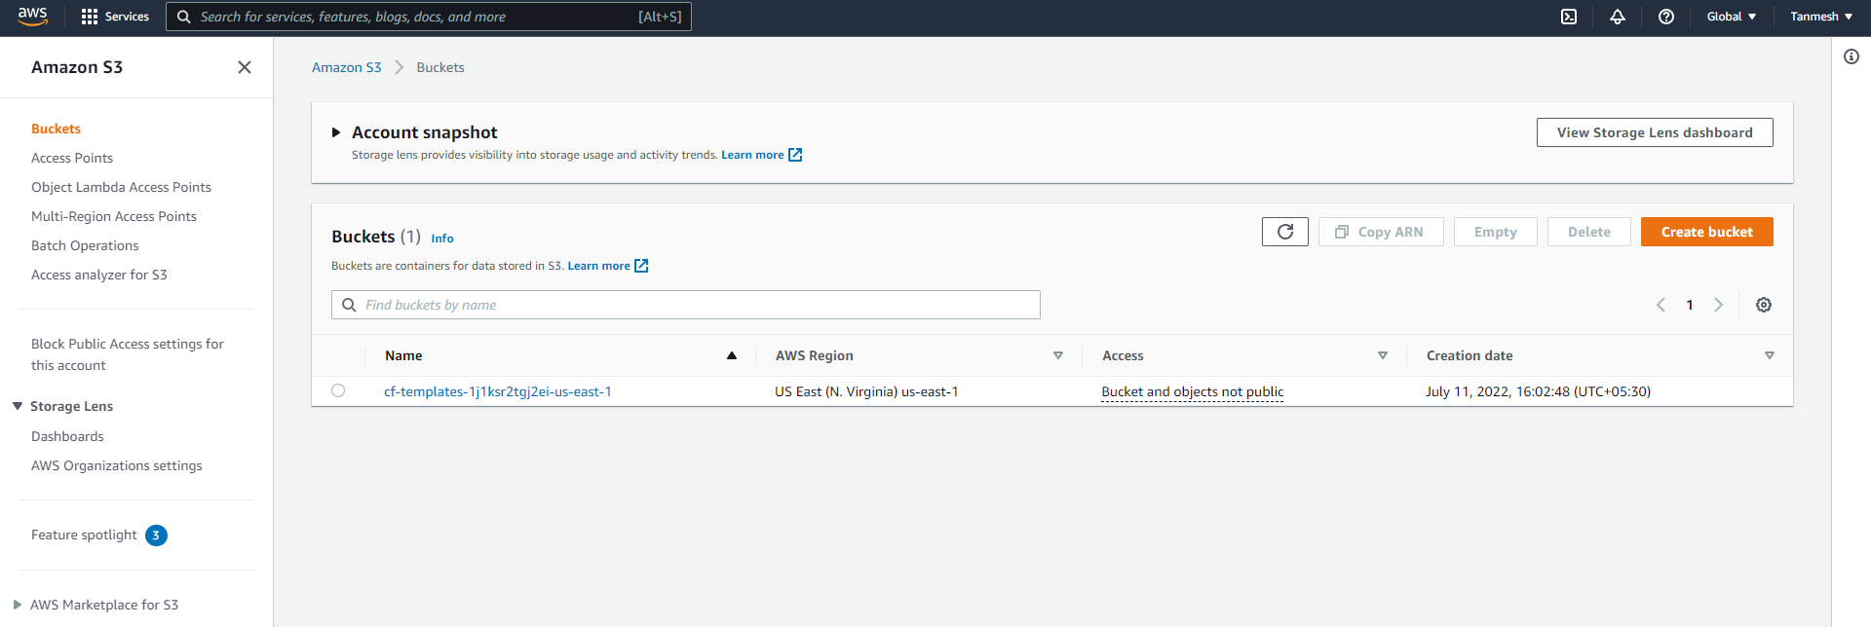

### Logs

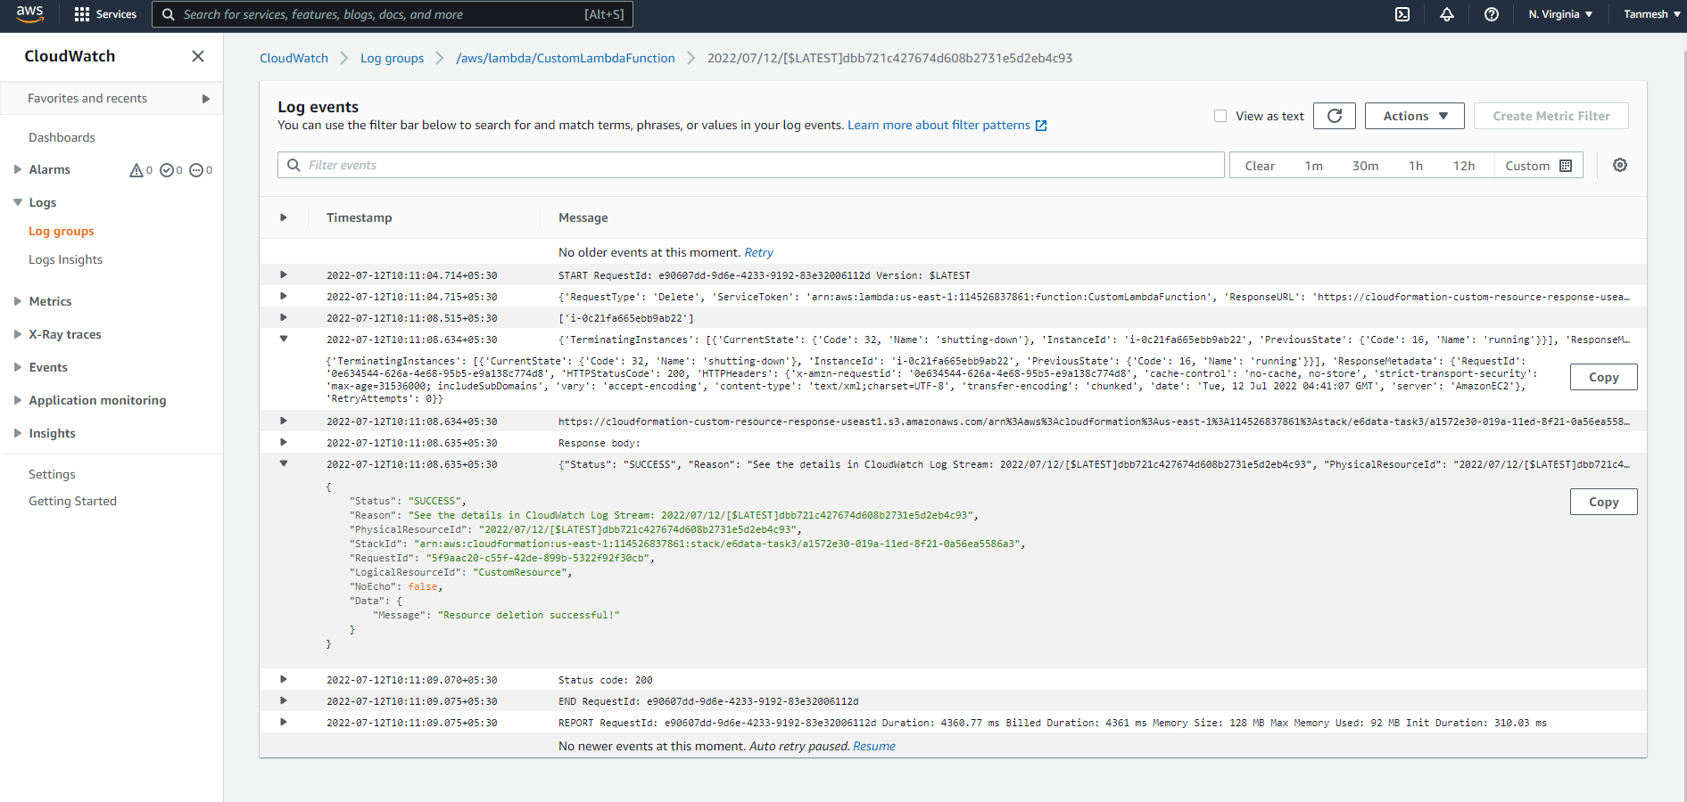

### Lambda Functions Deleted

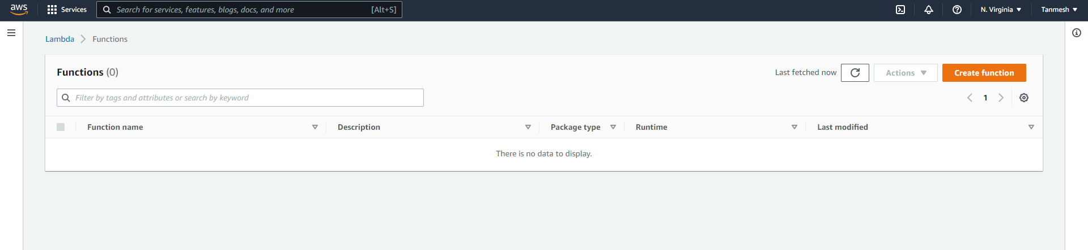

### IAM Roles

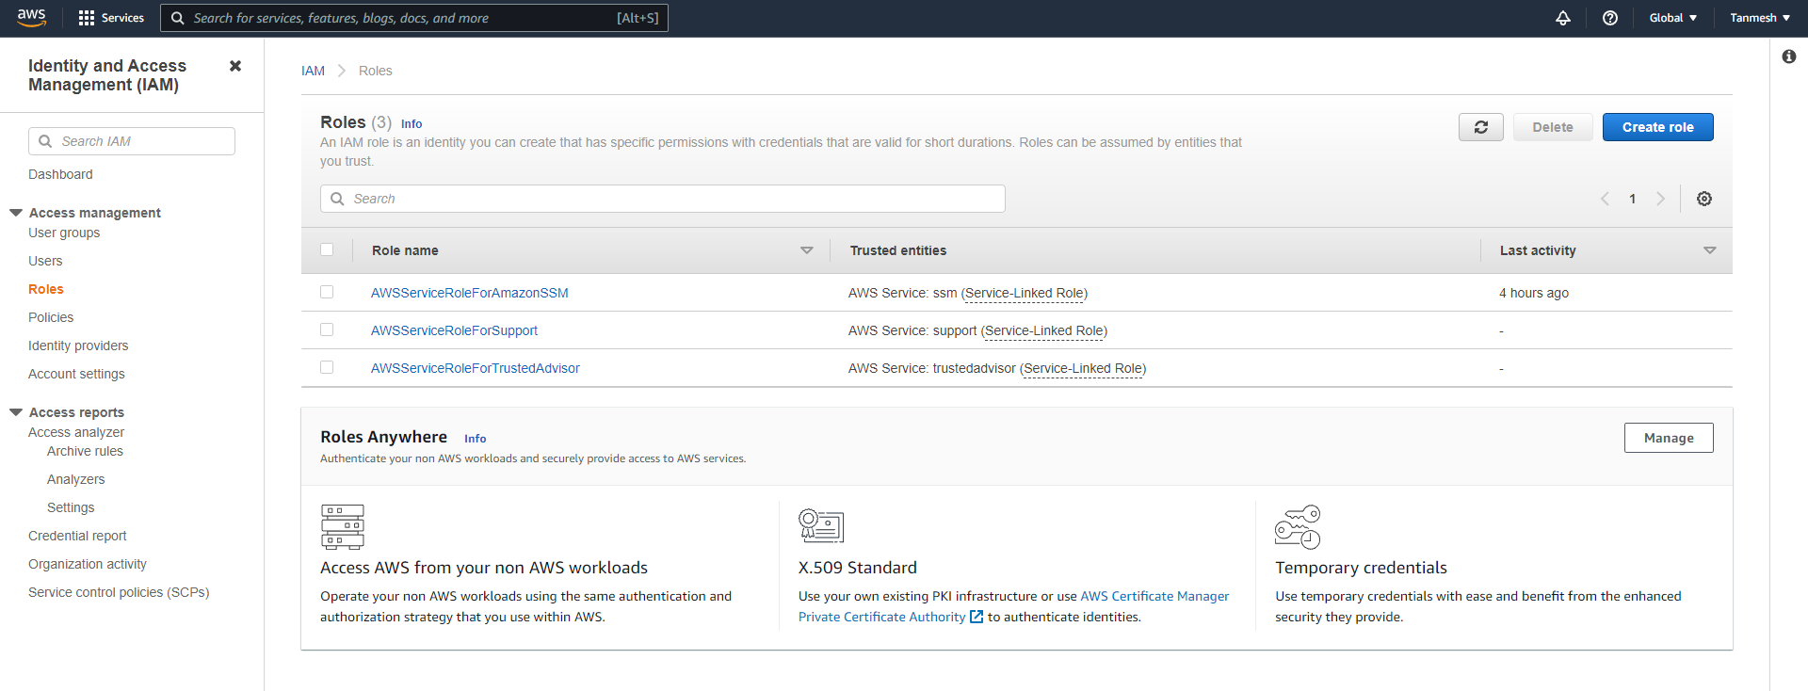

### CF Stack

